Functions

Look at this code:
def show_greeting():
print("Hello, Python learner!")
show_greeting()
print("Welcome to Python.")

What do you think this code will display?
Click or tap here to enter text.

Run the code. Compare the result with your prediction:
Click or tap here to enter text.

Let’s investigate! Answer the questions below:
- Why does Python not run a function body when it first reads the def statement?
Click or tap here to enter text.

- What happens if the function name is written without parentheses where a call is intended?
Click or tap here to enter text.

- Why must the function body be indented?
Click or tap here to enter text.

- Which two messages appear, and in what order?
Click or tap here to enter text.

Functions

Look at this code:
def show_greeting():
print("Hello, Python learner!")
show_greeting()
print("Welcome to Python.")

Use the code above to help you. After completing each challenge below, run your program to test that it works correctly. Save each completed challenge program in a new file.

Programming Challenges

Challenge 1
Rewrite only the message inside show_greeting() so a caller sees "Hello, coder!" The function name and call stay unchanged.
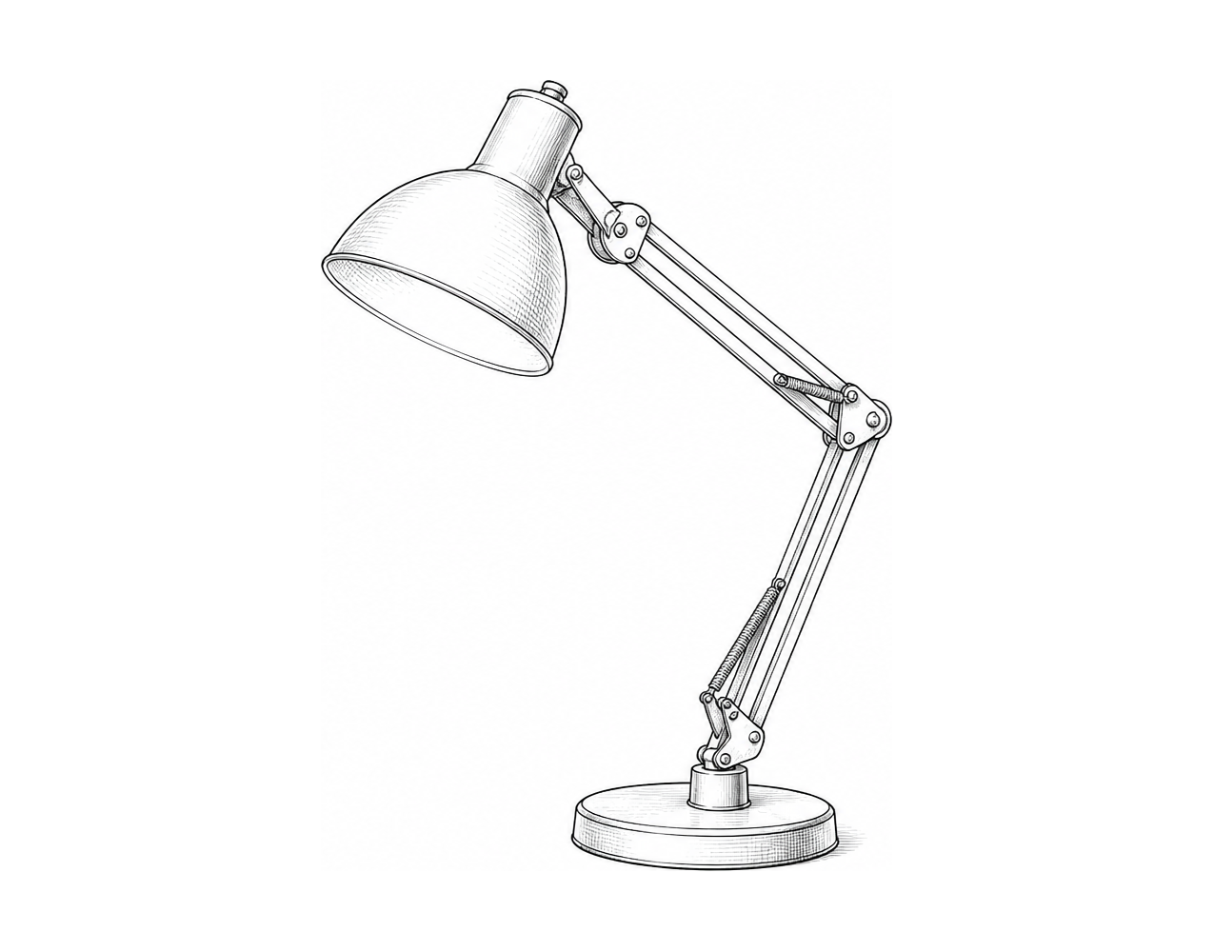

Challenge 2
A greeting is useful more than once. Add a second function call: call show_greeting() again so "Hello, Python learner!" appears twice. Predict the number of greetings before you run it.

Challenge 3
Build one no-input function called show_tip() that displays a Python tip of your choice. Call it twice; the same tip should appear two times.

Functions

Fix the code!

This code has errors! Look closely at the code to find the problems:

def show_greeting():
print(greeting_message)
show_greeting()
print("Welcome to Python.")

Rewrite the whole program in the box below with fixes to the errors.
Click or tap here to enter text.

After you are confident that you fixed all the errors, copy the code from the box and run it.

Did it work correctly on your first try? Did you find all the errors?
Click or tap here to enter text.

